Presentation

In this controller testing there are 3 parts: Visitor, User and Admin

**Visitor**

**Register**

If visitor want tot register, they need to press the register button. Visitor need to fill in email and password and the password should be having at least 6 characters long, one non letter or digit character and one lowercase and one

uppercase.

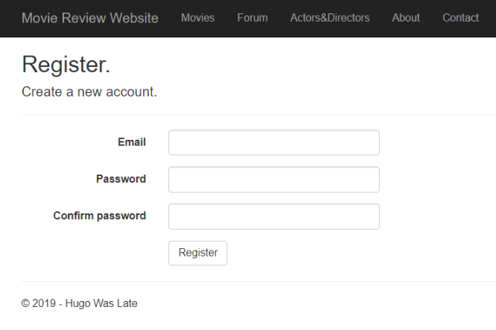

**Visit the page**

When visitor visit the page, they can visit movie, people and forum details. However, visitor cannot comment or reply the comment on it.

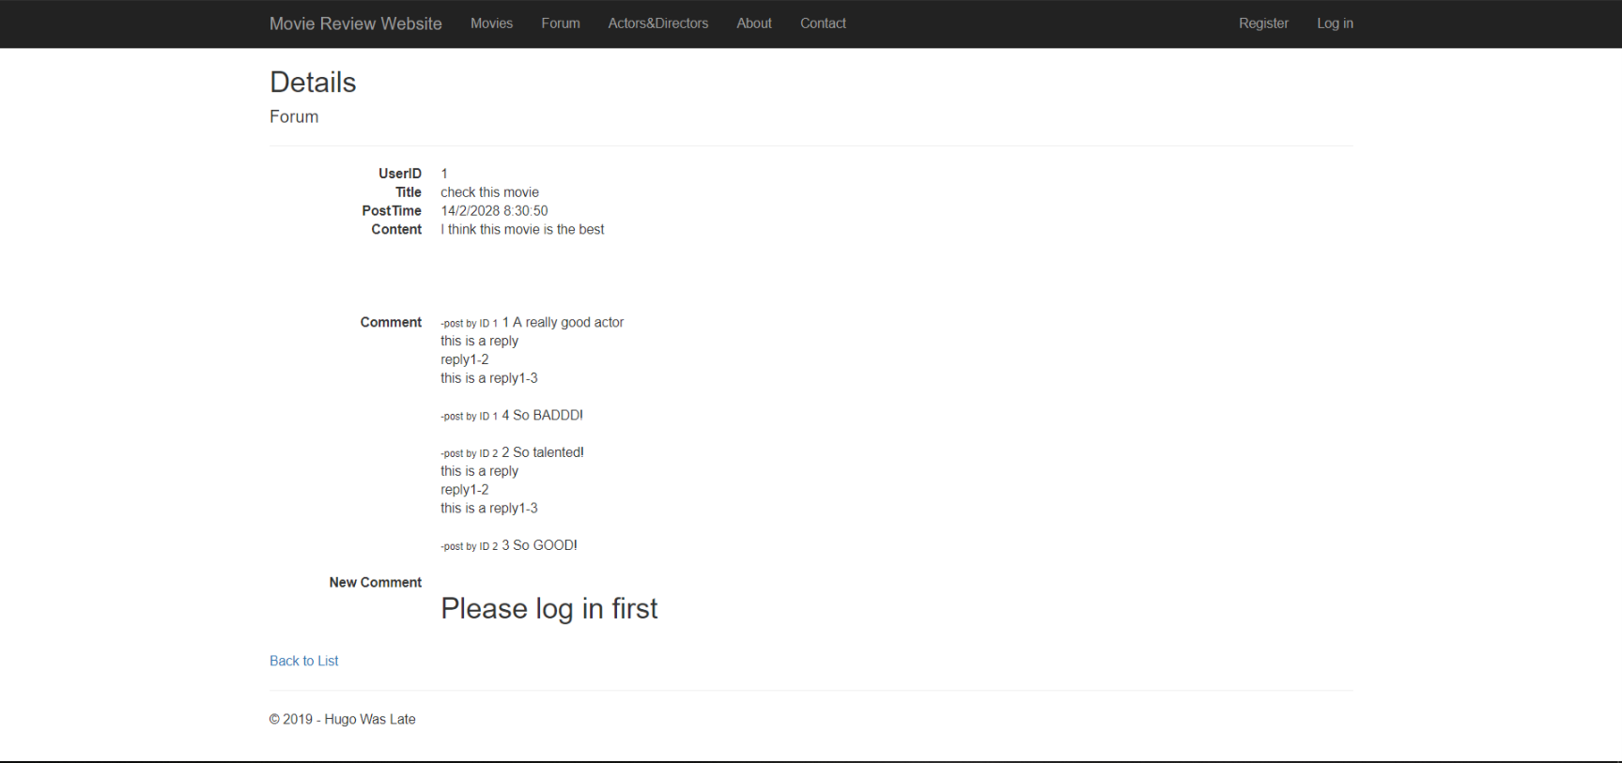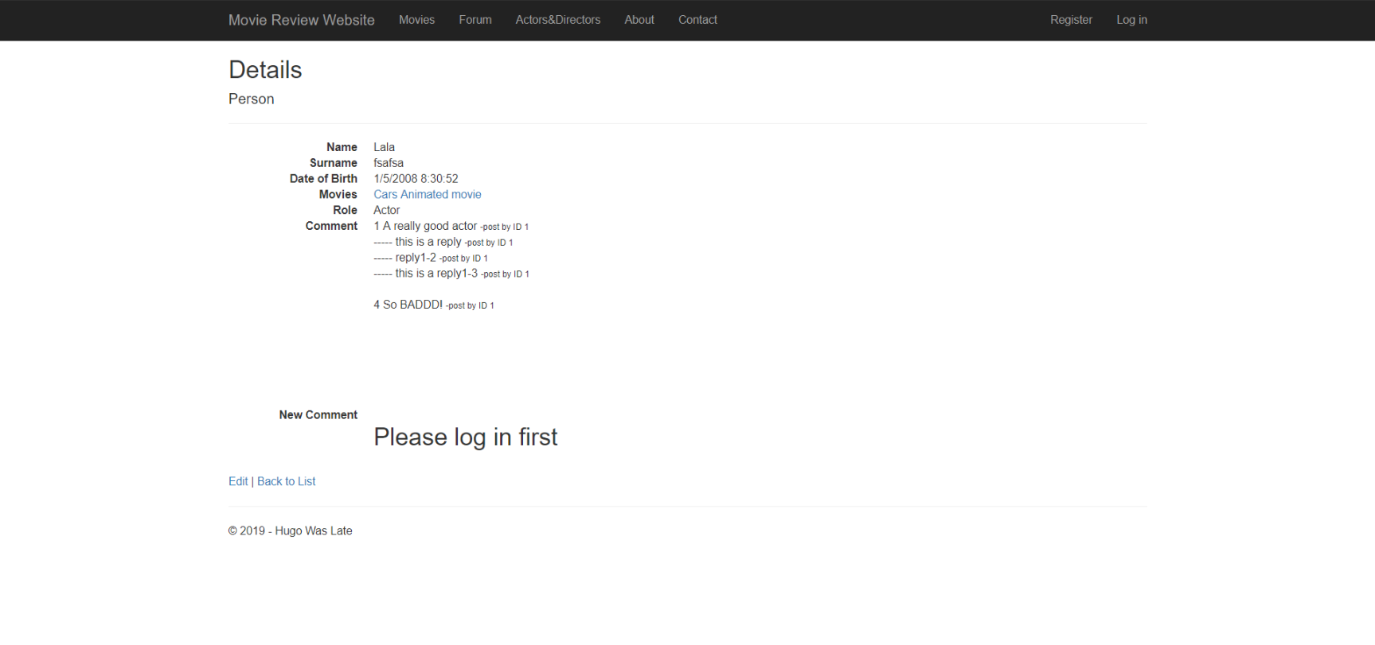

**Sort By**

Visitor can the tool sort the movie by genres and rating.

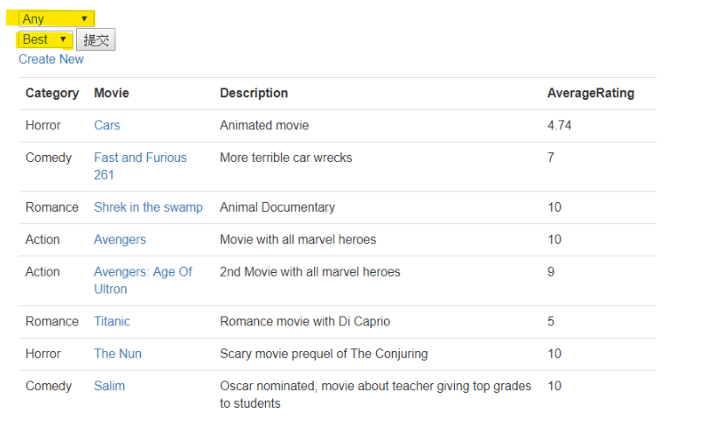

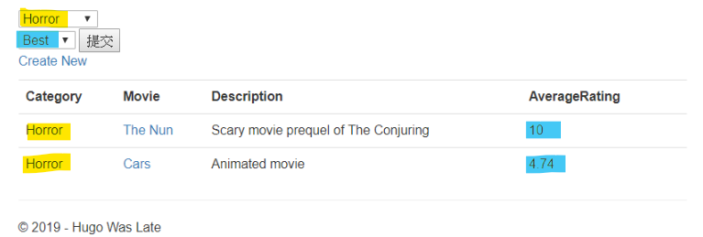

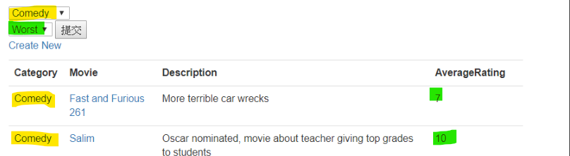

**User**

**Login**

User press the login button and enter the correct email and password. If the user success login, it will show the hello messenger.

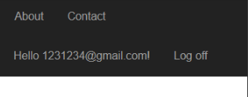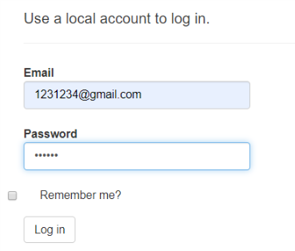

**Log off**

User can log off.

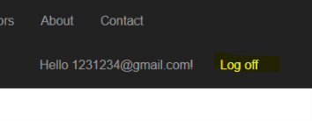

**Create new movie**

When user create new movie, user need to press the movie button and press “Create New”. And enter the information about movie in the form and press ‘Create’ button. That new movie will show up on the list. 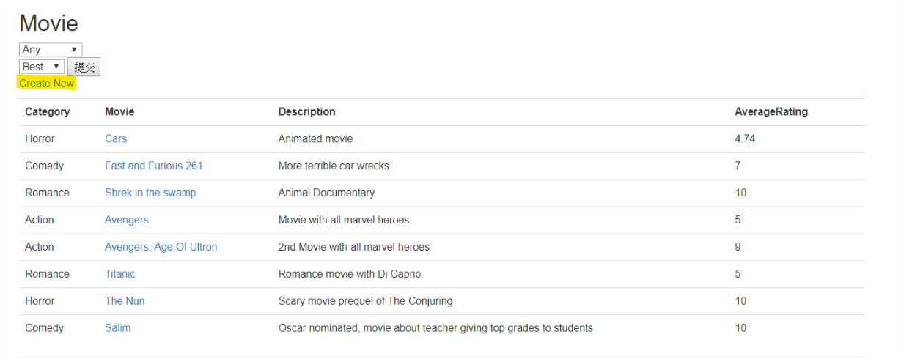

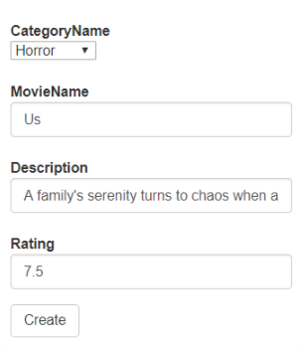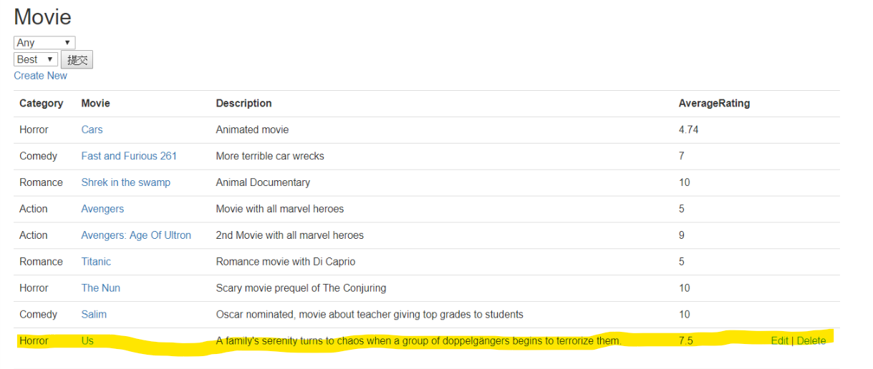

**Edit (In Movie, Forum and Actors&Directors)**

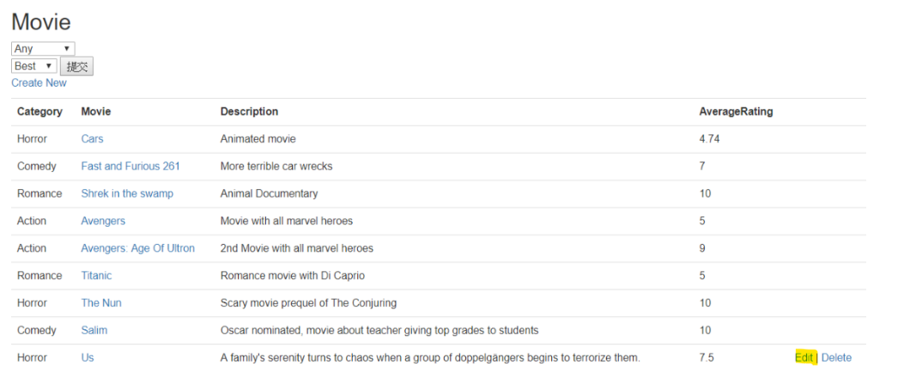When user type something wrong, when creating the post. User can press the “Edit” button, enter edit page correct the information and press “Save” button, and post will update.

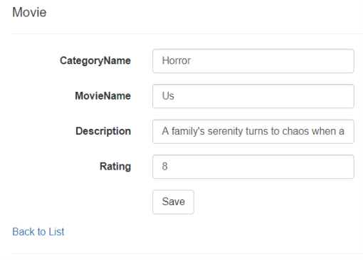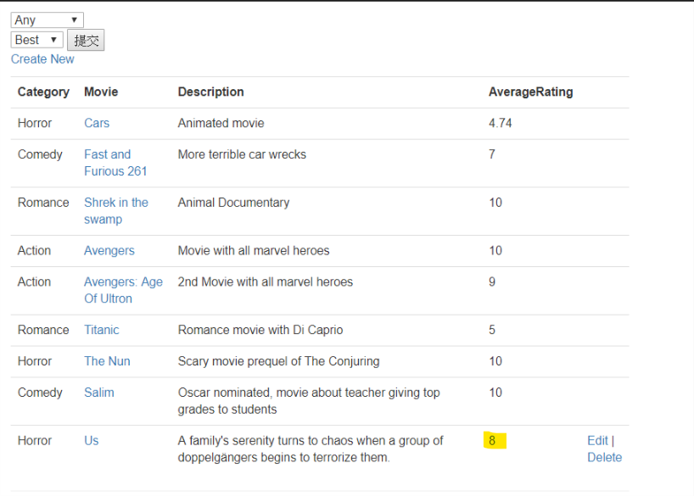

**Delete (In Movie, Forum and Actors&Directors)**

User can delete the post which is the user create. First, user press the” Delete” button next to post, and website will show the confirm page make sure user want to delete the movie. When user press “Delete” button on the confirm page, the post will be deleted.

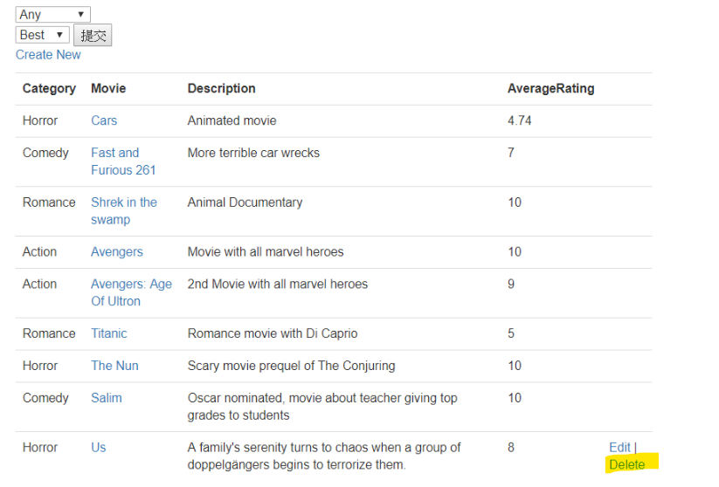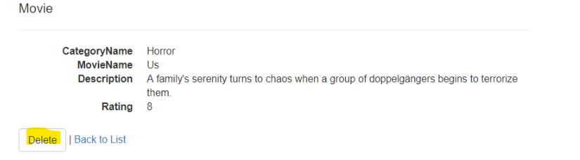

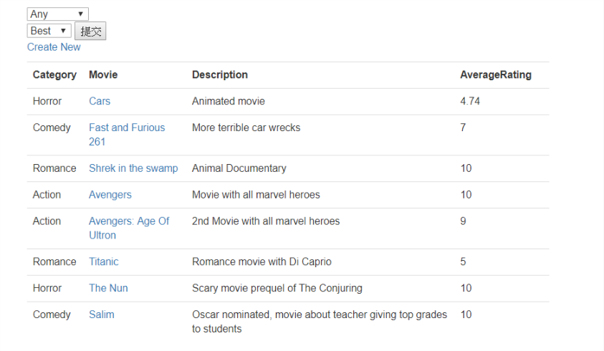

**Comments (In Movie, Forum and Actors&Directors)**

When user want to comment the details, user need to press one of the posts which user want to comment. And put the comments on the comments box and press “Send”. The comments and will display on the movie details.

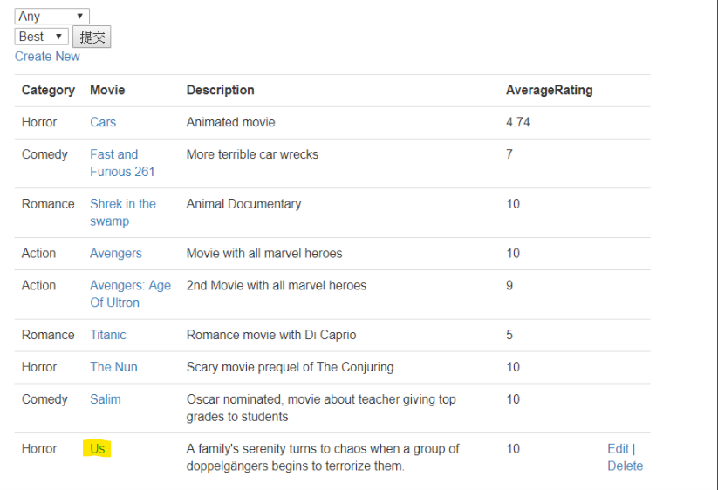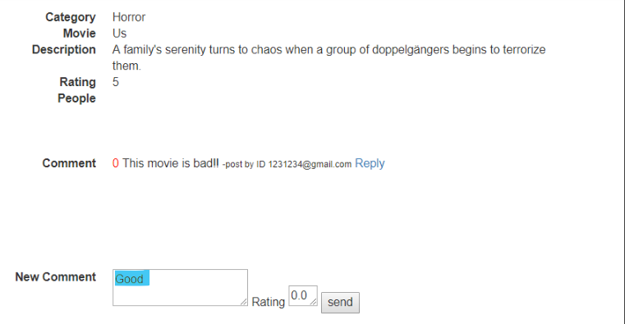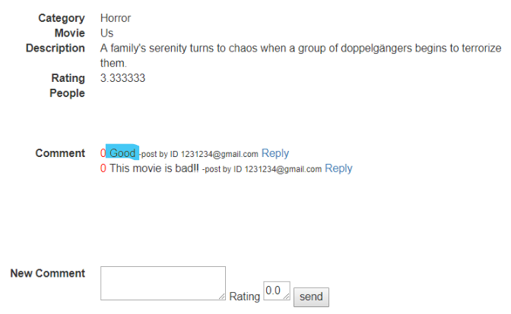

**Reply Comments**

When user want to reply other user comment, they can press the reply button beside the comments which user want to reply. And type the context press “Reply” button. 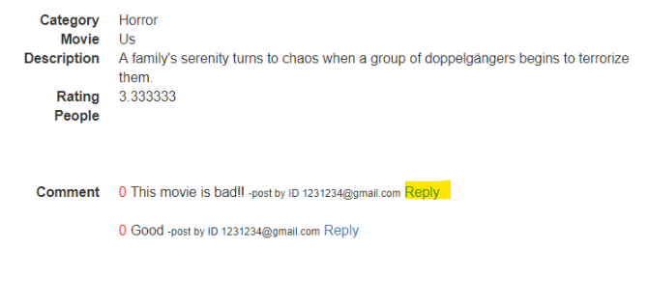

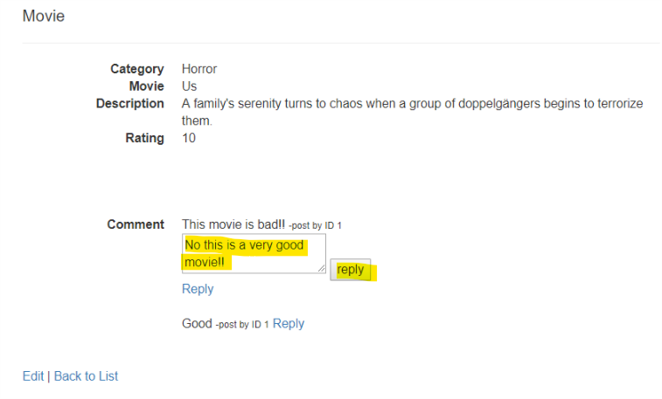

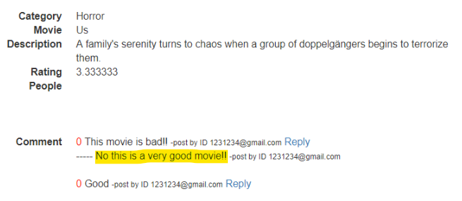

**Rating (Only on Movie)**

User can rate the movie, during user comments there are rating box next to the comments box. When user enter the number rating (0-10), and press “Reply”, user can see their rating and the average rating will be update.

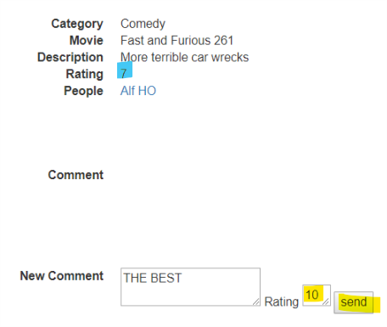

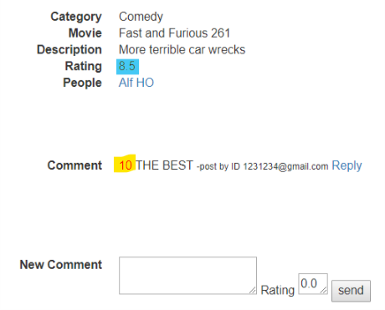

**Admin**

**Delete post (In Movie, Forum and Actors&Directors)**

Admin have permission to delete any movie, post in the forum or people page. When admin find out some post is aggressive, admin can ban delete the post form the movie, forum and the people page.

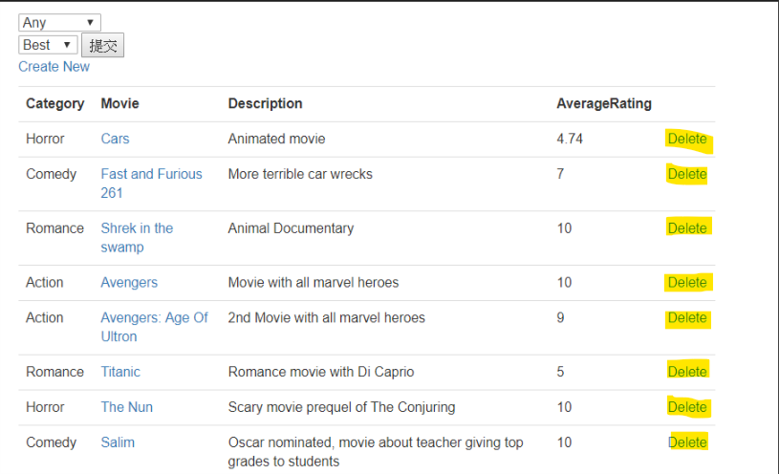

**Delete Comments ((In Movie, Forum and Actors&Directors)**

Admin have permission to delete comments.

